**Task 1 :**

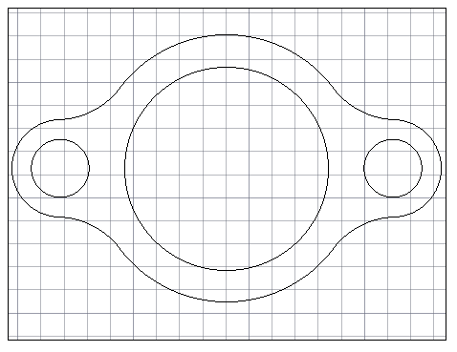

**Procedure:**

* Draw two circles with same center one of the diameter of 88 units and other of radius 58 units
* Draw line of 72 units on both sides of the drawn circle center
* Draw two circles one of the diameter 25 units and another of the radius 21 units on the ends of each drawn line
* Fillet the outside circles with radius 33 units at every side
* Trim the unwanted parts from the diagram

**Commands :**

|  |  |  |
| --- | --- | --- |
| Command: c  CIRCLE  Specify center point for circle or [3P/2P/Ttr (tan tan radius)]: r  Point or option keyword required.  Specify center point for circle or [3P/2P/Ttr (tan tan radius)]:  Specify radius of circle or [Diameter]: 58  Command:  Press ESC or ENTER to exit, or right-click to display shortcut menu.  Command: C  CIRCLE  Specify center point for circle or [3P/2P/Ttr (tan tan radius)]:  Specify radius of circle or [Diameter] <58.0000>: d  Specify diameter of circle <116.0000>: 88  Command: l  LINE  Specify first point:  Specify next point or [Undo]: <Ortho on> 72  Specify next point or [Undo]: *Cancel*  Command: CO  COPY  Select objects: 1 found  Select objects:  Current settings: Copy mode = Multiple  Erase source objects? [Yes/No] <No>: *Cancel*  Command:  Command: *Cancel*  Command: *Cancel*  Command: MI  MIRROR  Select objects: 1 found  Select objects: 1 found, 2 total  Select objects:  Specify first point of mirror line:  Specify second point of mirror line:  Erase source objects? [Yes/No] <No>:  Command:  MIRROR  Select objects: *Cancel*  Command: FI  FILTER  Command: *Cancel*  Command: F  FILLET  Current settings: Mode = NOTRIM, Radius = 5.0000  Select first object or [Undo/Polyline/Radius/Trim/Multiple]: r  Specify fillet radius <5.0000>: 33  Select first object or [Undo/Polyline/Radius/Trim/Multiple]: m  Select first object or [Undo/Polyline/Radius/Trim/Multiple]:  Select second object or shift-select to apply corner or [Radius]: | Specify base point or [Displacement/mOde] <Displacement>:  Specify second point or [Array] <use first point as displacement>: *Cancel*  Command: l  LINE  Specify first point:  Specify next point or [Undo]: 72  Specify next point or [Undo]: `*Cancel*  `  Command: c*Cancel*  Command: *Cancel*  Command: C  CIRCLE  Specify center point for circle or [3P/2P/Ttr (tan tan radius)]:  Specify radius of circle or [Diameter] <44.0000>: 21  Command: c  CIRCLE  Specify center point for circle or [3P/2P/Ttr (tan tan radius)]:  Specify radius of circle or [Diameter] <21.0000>: d  Specify diameter of circle <42.0000>: 25  Command: *Cancel*  Command: CO  [cuTting edges/Crossing/mOde/Project/eRase]:  Select object to trim or shift-select to extend or  [cuTting edges/Crossing/mOde/Project/eRase/Undo]:  Specify next fence point or [Undo]:  Select object to trim or shift-select to extend or  [cuTting edges/Crossing/mOde/Project/eRase/Undo]:  Specify next fence point or [Undo]:  Select object to trim or shift-select to extend or  [cuTting edges/Crossing/mOde/Project/eRase/Undo]:  Select object to trim or shift-select to extend or  [cuTting edges/Crossing/mOde/Project/eRase/Undo]:  Select object to trim or shift-select to extend or  [cuTting edges/Crossing/mOde/Project/eRase/Undo]:  Select object to trim or shift-select to extend or  [cuTting edges/Crossing/mOde/Project/eRase/Undo]:  \ | Select objects: 1 found  Select objects: 1 found, 2 total  Select objects:  Current settings: Copy mode = Multiple  Specify base point or [Displacement/mOde] <Displacement>:  Specify second point or [Array] <use first point as displacement>: *Cancel*  Command: MI  MIRROR  Select objects: Specify opposite corner: 0 found  Select objects: 1 found  Select objects: 1 found, 2 total  Select objects:  Specify first point of mirror line:  Specify second point of mirror line:  Invalid 2D point.  Specify second point of mirror line: *Cancel*  Command: MI  MIRROR  Select objects: 1 found  Select objects: 1 found, 2 total  Select objects:  Specify first point of mirror line:  Specify second point of mirror line:  [cuTting edges/Crossing/mOde/Project/eRase/Undo]:  Select object to trim or shift-select to extend  or  [cuTting edges/Crossing/mOde/Project/eRase/Undo]:  Select object to trim or shift-select to extend or  [cuTting edges/Crossing/mOde/Project/eRase/Undo]: *Cancel*  Command:  Command: <Switching to: Layout1>  Regenerating layout.  Regenerating layout.  Regenerating model - caching viewports.  Command: Specify opposite corner or [Fence/WPolygon/CPolygon]:  Command: *Cancel*  Command: _.MSPACE  Select object to trim or shift-select to extend or  Command:  Press ESC or ENTER to exit, or right-click to display shortcut menu.  Command: _.PSPACE  Command:  Automatic save to C:\Users\fahim\AppData\Local\Temp\lab 06_1_15560_c9cd3709.sv$ ... |

**Task 2:**

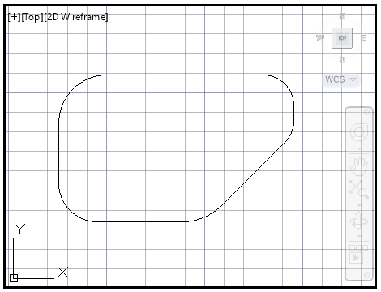

**Procedure:**

* Draw a rectangle of length 120 units and width 75 units
* Fillet the top left and bottom left corner with radius 25 units and 20 units respectively
* Champher the bottom right corner with angle 45 degree
* Fillet the top right and bottom right corner with radius 15 and 30 units respectively
* Trim the unwanted parts from the figure

**Commands:**

|  |  |  |
| --- | --- | --- |
| Command: RE  REGEN Regenerating model.  Command: *Cancel*  Command: REC  RECTANG  Specify first corner point or [Chamfer/Elevation/Fillet/Thickness/Width]:  Specify other corner point or [Area/Dimensions/Rotation]: d  Specify length for rectangles <10.0000>: 120  Specify width for rectangles <10.0000>: 75  Specify other corner point or [Area/Dimensions/Rotation]:  Crossing Lasso Press Spacebar to cycle options  Command:  Press ESC or ENTER to exit, or right-click to display shortcut menu.  Command: F  FILLET  Current settings: Mode = NOTRIM, Radius = 30.0000  Select first object or [Undo/Polyline/Radius/Trim/Multiple]: r  Specify fillet radius <30.0000>: 15  Select first object or  Select first object or [Undo/Polyline/Radius/Trim/Multiple]: r  Specify fillet radius <33.0000>: 25  Select first object or [Undo/Polyline/Radius/Trim/Multiple]:  [Undo/Polyline/Radius/Trim/Multiple]:  Select second object or shift-select to apply corner or [Radius]:  Command: *Cancel*  Command: TR  TRIM  Current settings: Projection=View, Edge=None, Mode=Quick  Select object to trim or shift-select to extend or  [cuTting edges/Crossing/mOde/Project/eRase]:  Select object to trim or shift-select to extend or  [cuTting edges/Crossing/mOde/Project/eRase/Undo]:  Specify next fence point or [Undo]:  Specify next fence point or [Undo]:  Select object to trim or shift-select to extend or | Select second object or shift-select to apply corner or [Radius]:  Command: *Cancel*  Command: FILLET  Current settings: Mode = NOTRIM, Radius = 25.0000  Select first object or [Undo/Polyline/Radius/Trim/Multiple]: r  Specify fillet radius <25.0000>: 20  Select first object or [Undo/Polyline/Radius/Trim/Multiple]:  Select second object or shift-select to apply corner or [Radius]:  Command: FILLET  [cuTting edges/Crossing/mOde/Project/eRase/Undo]:  Select object to trim or shift-select to extend or  [cuTting edges/Crossing/mOde/Project/eRase/Undo]:  Select object to trim or shift-select to extend or  Command: *Cancel*  Select first object or [Undo/Polyline/Radius/Trim/Multiple]:  Select second object or shift-select to apply corner or [Radius]:  Select second object or shift-select to apply corner or [Radius]:  Command: *Cancel*  Command: CH  PROPERTIES  [cuTting edges/Crossing/mOde/Project/eRase/Undo]:  Select object to trim or shift-select to extend or  [cuTting edges/Crossing/mOde/Project/eRase/Undo]:  Select object to trim or shift-select to extend or  [cuTting edges/Crossing/mOde/Project/eRase/Undo]:  Select object to trim or shift-select to extend or  [cuTting edges/Crossing/mOde/Project/eRase/Undo]:  Select object to trim or shift-select to extend or | Command: Specify opposite corner or [Fence/WPolygon/CPolygon]: *Cancel*  Command:  Press ESC or ENTER to exit, or right-click to display shortcut menu.  Command: CHA  CHAMFER  (NOTRIM mode) Current chamfer Dist1 = 0.0000, Dist2 = 0.0000  Select first line or [Undo/Polyline/Distance/Angle/Trim/mEthod/Multiple]: a  Specify chamfer length on the first line <0.0000>: 45  Specify chamfer angle from the first line <0>: 45  Command: <Switching to: Layout1>  Regenerating layout.  Regenerating model - caching viewports.  Command: Specify opposite corner or [Fence/WPolygon/CPolygon]: *Cancel*  Command: _.MSPACE  Command:  Press ESC or ENTER to exit, or right-click to display shortcut menu. |

**Task 3:**

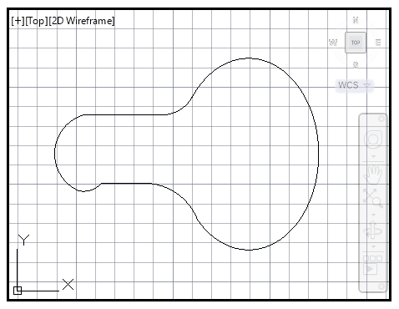

**Procedure:**

* Draw a line of line of 85 units
* Draw a polygon of 36 units at right and 15 units at left
* Offset the line with distance 20 on both sides
* Fillet the both the polygon with the line
* Trim the unwanted parts from the diagram

**Commands:**

|  |  |  |
| --- | --- | --- |
| Command: l  LINE  Specify first point: 85  Specify next point or [Undo]:  Specify next point or [Undo]: *Cancel*  Command: LINE  Specify first point:  Specify next point or [Undo]: 85  Specify next point or [Undo]: *Cancel*  Command: o  OFFSET  Current settings: Erase source=No Layer=Source OFFSETGAPTYPE=0  Specify offset distance or [Through/Erase/Layer] <Through>: 20  Select object to offset or [Exit/Undo]  Command:  ** STRETCH **  Specify stretch point or [Base point/Copy/Undo/eXit]: *Cancel*  Command: Specify opposite corner or [Fence/WPolygon/CPolygon]: *Cancel*  Command: f  FILLET  Current settings: Mode = NOTRIM, Radius = 15.0000  Select first object or [Undo/Polyline/Radius/Trim/Multiple]: r  Specify fillet radius <15.0000>: 18  Select first object or [Undo/Polyline/Radius/Trim/Multiple]:  Select second object or shift-select to apply corner or [Radius]:  Command: L  LINE  Specify first point:  Specify next point or [Undo]:  Specify next point or [Undo]: *Cancel*  Command: FILLET  Current settings: Mode = NOTRIM, Radius = 18.0000  Select first object or  No valid fillet with radius 43.0000  Select second object or shift-select to apply corner or [Radius]:  Command:  Command: _pline  Specify start point:  Current line-width is 0.0000  [cuTting edges/Crossing/mOde/Project/eRase/Undo]:  Select object to trim or shift-select to extend or  Select object to trim or shift-select to extend or  ** STRETCH **  Specify stretch point or [Base point/Copy/Undo/eXit]:  Command: *Cancel*  Command: TR  TRIM  Current settings: Projection=View, Edge=None, Mode=Quick | Command: _arc  Specify start point of arc or [Center]:  Specify second point of arc or [Center/End]: _e  Specify end point of arc:  Specify center point of arc (hold Ctrl to switch direction) or [Angle/Direction/Radius]: _a  Specify included angle (hold Ctrl to switch direction): 15  Command:  Command:  ** STRETCH **  Specify stretch point or [Base point/Copy/Undo/eXit]:  Command: *Cancel*  Command:  Press ESC or ENTER to exit, or right-click to display shortcut menu.  Command: c  CIRCLE  Specify center point for circle or [3P/2P/Ttr (tan tan radius)]:  Specify radius of circle or [Diameter]:  Command: F  Specify next point or [Arc/Close/Halfwidth/Length/Undo/Width]:  Command:  ** STRETCH **  Specify stretch point or [Base point/Copy/Undo/eXit]:  Command: Specify opposite corner or [Fence/WPolygon/CPolygon]: *Cancel*  Command: *Cancel*  Command: FILLET  Current settings: Mode = NOTRIM, Radius = 43.0000  Select first object or [Undo/Polyline/Radius/Trim/Multiple]: r  Specify fillet radius <43.0000>: 43  Select first object or [Undo/Polyline/Radius/Trim/Multiple]:  Select second object or shift-select to apply corner or [Radius]:  TRIM  Current settings: Projection=View, Edge=None, Mode=Quick  Select object to trim or shift-select to extend or  [cuTting edges/Crossing/mOde/Project/eRase]:  Select object to trim or shift-select to extend or  [cuTting edges/Crossing/mOde/Project/eRase/Undo]: *Cancel*  Command:  Press ESC or ENTER to exit, or right-click to display shortcut menu.  Command: *Cancel*  Command: <Switching to: Layout1>  Restoring cached viewports - Regenerating layout. | FILLET  Current settings: Mode = NOTRIM, Radius = 15.0000  Select first object or [Undo/Polyline/Radius/Trim/Multiple]: r  Specify fillet radius <15.0000>: 18  Select first object or [Undo/Polyline/Radius/Trim/Multiple]:  Select second object or shift-select to apply corner or [Radius]:  Command:  Command:  ** STRETCH **  Specify stretch point or [Base point/Copy/Undo/eXit]:  Command: *Cancel*  Command: _u Grip Edit  Command: _u FILLET  Command: _u INTELLIZOOM INTELLIZOOM  Crossing Lasso Press Spacebar to cycle options  Press ESC or ENTER to exit, or right-click to display shortcut menu.  ** STRETCH **  Specify next point or [Arc/Halfwidth/Length/Undo/Width]: <Ortho off>  Specify next point or [Arc/Close/Halfwidth/Length/Undo/Width]:  Specify stretch point or [Base point/Copy/Undo/eXit]:  Command:  ** STRETCH **  Specify stretch point or [Base point/Copy/Undo/eXit]:  Command: Specify opposite corner or [Fence/WPolygon/CPolygon]: *Cancel*  Command: *Cancel*  Command: TR  TRIM  Current settings: Projection=View, Edge=None, Mode=Quick  Select object to trim or shift-select to extend or  [cuTting edges/Crossing/mOde/Project/eRase/Undo]:  Select object to trim or shift-select to extend or  Select object to trim or shift-select to extend or  [cuTting edges/Crossing/mOde/Project/eRase/Undo]:  [cuTting edges/Crossing/mOde/Project/eRase/Undo]: *Cancel*  Command:  Command:  ** STRETCH **  Specify stretch point or [Base point/Copy/Undo/eXit]: |

**Task 4:**

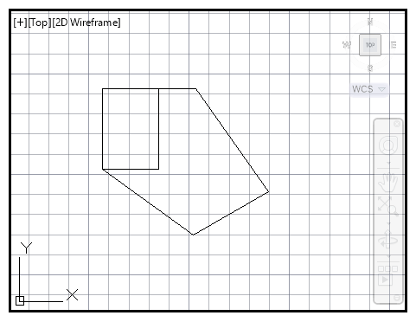

**Procedure:**

* Draw two lines of 40 , 40 units perpendicularly
* Draw line of 40 with angle of 45 degree at bottom line
* Draw another line of 60 units with angle of 105 degree
* Draw perpendicular line to the previous line and join to the first line

**Commands:**

|  |  |  |
| --- | --- | --- |
| Command: l  LINE  Specify first point:  Specify next point or [Undo]: 40  Specify next point or [Undo]: *Cancel*  Command: LINE  Specify first point:  Specify next point or [Undo]: 40  Specify next point or [Undo]: <Polar on> 40  Specify next point or [Close/Undo]: 60  Specify next point or [Close/Undo]: <Ortho on> <Ortho off> <Polar on>  Specify next point or [Close/Undo]:  Specify next point or [Close/Undo]: *Cancel*  Command:  Command:  ** STRETCH **  Specify stretch point or [Base point/Copy/Undo/eXit]: <Ortho on> *Cancel*  Command:  ** STRETCH **  Specify stretch point or [Base point/Copy/Undo/eXit]:  Command: *Cancel*  Command: tr  TRIM  Current settings: Projection=View, Edge=None, Mode=Quick  ** STRETCH **  Specify stretch point or [Base point/Copy/Undo/eXit]:  Command: *Cancel*  Command:  ** STRETCH **  Specify stretch point or [Base point/Copy/Undo/eXit]:  Command: Specify opposite corner or [Fence/WPolygon/CPolygon]: *Cancel*  Command:  ** STRETCH **  Specify stretch point or [Base point/Copy/Undo/eXit]:  Command: | Select object to trim or shift-select to extend or  [cuTting edges/Crossing/mOde/Project/eRase]:  Select object to trim or shift-select to extend or  [cuTting edges/Crossing/mOde/Project/eRase/Undo]: *Cancel*  Command: o  OFFSET  Current settings: Erase source=No Layer=Source OFFSETGAPTYPE=0  Specify offset distance or [Through/Erase/Layer] <Through>: 40  Select object to offset or [Exit/Undo] <Exit>:  Specify point on side to offset or [Exit/Multiple/Undo] <Exit>:  Select object to offset or [Exit/Undo] <Exit>: *Cancel*  Command: l  LINE  Specify first point:  Specify next point or [Undo]:  Specify next point or [Undo]: *Cancel*  Command:  Press ESC or ENTER to exit, or right-click to display shortcut menu.  Command:  Command:  [cuTting edges/Crossing/mOde/Project/eRase/Undo]:  Select object to trim or shift-select to extend or  [cuTting edges/Crossing/mOde/Project/eRase/Undo]: *Cancel*  Command:  Command:  ** STRETCH **  Specify stretch point or [Base point/Copy/Undo/eXit]:  Command: *Cancel*  Command: <Switching to: Layout1>  Restoring cached viewports - Regenerating layout.  Regenerating 8 modified entities.  Command: Specify opposite corner or [Fence/WPolygon/CPolygon]:  Command:  Press ESC or ENTER to exit, or right-click to display shortcut menu.  Command:  Automatic save to | ** STRETCH **  Specify stretch point or [Base point/Copy/Undo/eXit]: <Polar on>  Command: *Cancel*  Command:  Command:  Specify stretch point or [Base point/Copy/Undo/eXit]:  Command: *Cancel*  Command:  Command:  ** STRETCH **  Specify stretch point or [Base point/Copy/Undo/eXit]:  Command: *Cancel*  Command:  Press ESC or ENTER to exit, or right-click to display shortcut menu.  Command: *Cancel*  Specify stretch point or [Base point/Copy/Undo/eXit]:  Command: *Cancel*  Command: tr  TRIM  Current settings: Projection=View, Edge=None, Mode=Quick  Select object to trim or shift-select to extend or  [cuTting edges/Crossing/mOde/Project/eRase]:  Select object to trim or shift-select to extend or  [cuTting edges/Crossing/mOde/Project/eRase/Undo]:  Select object to trim or shift-select to extend or  C:\Users\fahim\AppData\Local\Temp\lab 06_1_18050_64aefc06.sv$ ... |